- I created a new scene called “Title Screen”…this will be the main menu screen for players. If you look in the hierarchy you will see various images. I pretty much set up how everything should look like when the game starts. I want to go from this main screen to the actually game.
- Title Screen
  - At the title screen player will have various potions to choose from. They should be able to toggle up and down these options with a keybord or just select it with a mouse (Mouse select for now). But for your current job, you will only use the “Game Show” button. I don’t have the colors yet for which “Game Show” is highlighted and then selected…not yet anyway.

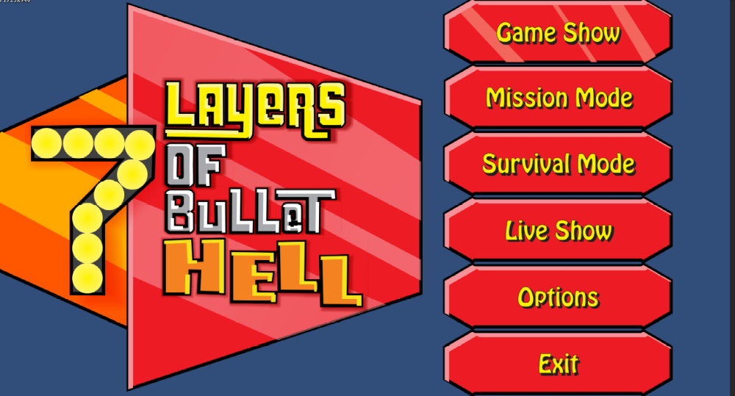
  - “Game Show” is just your regular instant pick up and play. But It will add together all the other items you unlock in “mission mode”. It also will have secrets of its own, but that’s a little more down the road.
- Contestant Select Screen
  - When player selects “Game Show” the screen instantly transitions to the “Contestant Select Menu”.
  - Here the player can choose from four randomly created contestants to play as.
  - Random Stat Creator
    - All base stats begin at
        - HP = 25
        - Every other stat begins at 1.
        - The various Mods can only be acquired once per character roll.
      - Step 1
        - Male or Female
      - Step 2
        - Skin color
        - Select one of the three race skills.
      - Step 3 (Assign stat points)
        - During character creation, each contestant will place 10 points in various stats.
        - HP
          - increased by 25 for each point
        - Melee Damage +1
        - Gun Damage +1
        - Bullet Range +1
        - Bullet Speed +1
        - Firing Speed +1
        - Accuracy +1
        - Total Ammo
          - Increased by 5 for each point
        - Movement Speed +1
        - Jump Height +1
        - Armor
          - Get 1 random Armor Mod
        - Cyborg
          - Get 1 random Cyborg Armor part
        - DNA Mod
          - Get 1 random DNA Mod
        - Gun Mod
          - Get 1 random Gun Mod
        - Melee Mod
          - Get 1 random Melee Mod
        - Grenade Mod
          - Get 1 random Grenade Mod
        - Super
          - Get 1 random Super Ability
    - Currently I have only the male and female black characters, but there will be four other races and two secret one.
  - At the top of each of the four panels is a visual of how the contestant will look like. Beneath Each of the four contestants will be there stats. With bars that display how much points are in each of the 8 categories. Each stat category goes up to 10.
    - Ignore the text on the silver, orange and red panels…we will be going with the icons of the yellow panel.
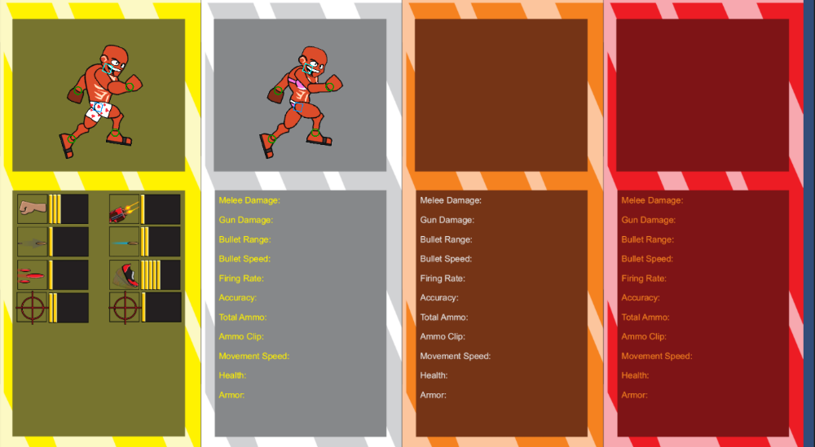
  - There will be an icon that will indicate which character is currently selected…maybe have the one selected run…but stop if no longer selected.
  - When character is selected…screen fades to black before running the random generator and creating the first room.
  - There might be one more sequence before entering the actually level…maybe a segment that shows what level the player is currently playing.

